**REGex Software Services**

**Java Full Stack Development Program**

Registration I'd:  **IIPRSS1404**

Name: **Shanmukh Subhash Kumbhar**

# Subject: Assignment 20 - #Collection frameworks session 3

a 2021 **Core Java Session 20 Assignments**

**Assignment - 1:**

Write a java program and represent the fallowing elements in **HashMap** object using generic syntax.

|  |  |
| --- | --- |
| **Course Name** | **Duration** |
| **Java Full Stack** | **150** |
| **Python Full Stack** | **150** |
| **UI Full Stack** | **80** |

Iterate one by one entry using **for-each loop**.

**Assignment - 2:**

Write a java program and represent the fallowing elements in **LinkedHashMap** object using generic syntax.

|  |  |
| --- | --- |
| **Course Name** | **Duration** |
| **Java Full Stack** | **150** |
| **Python Full Stack** | **150** |
| **UI Full Stack** | **80** |

Iterate one by one entry using **for-each loop**.

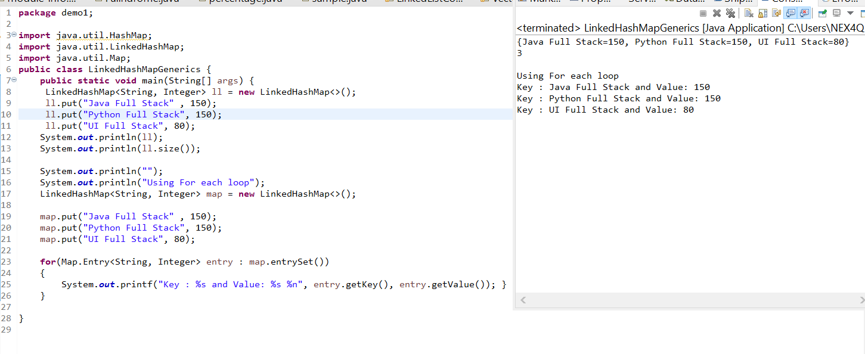

**Assignment - 3:**

Write a java program and represent the fallowing elements in **TreeMap** object using generic syntax.

|  |  |
| --- | --- |
| **Course Name** | **Duration** |
| **Java Full Stack** | **150** |
| **Python Full Stack** | **150** |
| **UI Full Stack** | **80** |

Iterate one by one entry using **for-each loop** 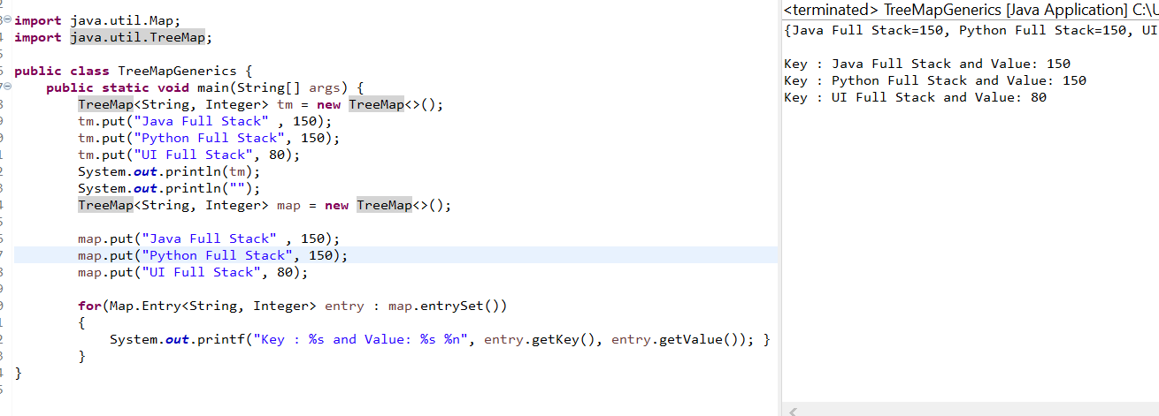

**Assignment - 4:**

Create a ***course_details.properties*** file and store the fallowing information.

|  |  |
| --- | --- |
| **Course Name** | **Duration** |
| **Java Full Stack** | **150** |
| **Python Full Stack** | **150** |
| **UI Full Stack** | **80** |

Write a java program and load the ***course_details.properties*** using Properties object and access all properties and display them on console.

